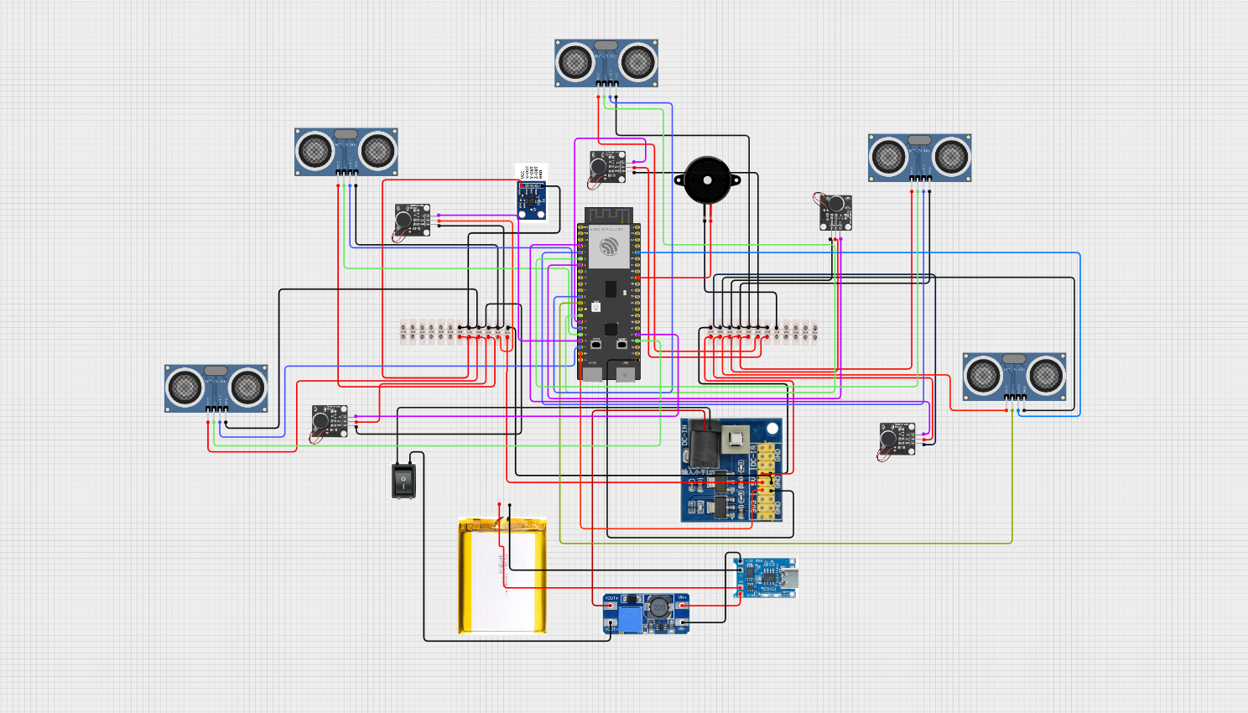
CUSLIUM V5 SCHEMATIC DIAGRAM
CREATED BY: ARDEE ROI U. OBEDENCIA
LEGENDS:
POWER
RED(VCC)
BLACK(GND)
ULTRASONIC SENSOR
BLUE(ECHO)
GREEN(TRIG)
VIBRATION MODULE
VIOLET(IN)

